Pinot Grigio
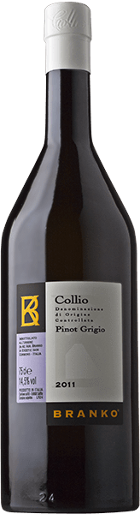
Like many other varieties, Pinot Grigio was imported from France and it is to the excellence the grape achieves here that the Collio owes much of its fame. This fruit-forward, characterful wine melds very special aromas from fermentation and partial maturation in oak, its initial swagger giving way to more harmonious perceptions that thrill the senses. Sun-dried hay and walnutskin aromas accompany nectarines and confectioner’s cream, comparisons that spring instinctively, and very clearly, to mind. The warm, plush mouthfeel with its discreet acidity and pleasing sensation of elegant fullness derives from the fact that at least ten per cent of the wine is conditioned in mid-sized oak casks.

