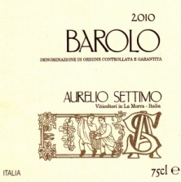

BAROLO DOCG

Tasting notes
In this great vintage, our Barolo is coloured deep garnet red with orange highlights.
The ethereal bouquet shows marked hints of the wood and liquorice typical of traditional-style wines aged in large casks.
On the mouth it is pleasantly dry, with soft, well-balanced tannins.

Basic informations
Product Name: Barolo DOCG
Cépage: Nebbiolo
Appellation: Barolo
Classificaton: DOCG
Colour: Red
Type: Still
Country/Region: Italy, Piedmont
Vintage: 2010
Alcohol percentage: 14 %
Sugar rate: <0.2 g/l
Ageing: 12 months in concrete tanks, 24 months in big oak casks of French wood
Number of bottles produced: 4,266

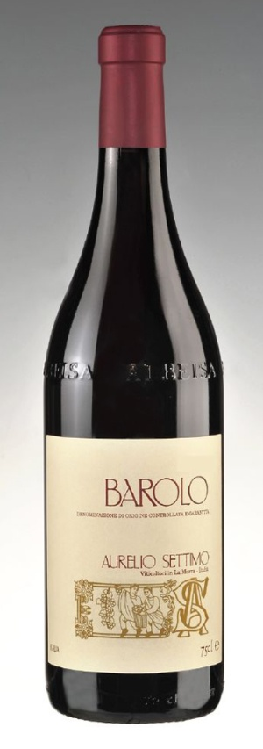
Vinification (Wine-making)
Method: according to tradition: fairly lengthy fermentations on the skins (submerged cap for 15-20 days), with frequent breaking up of the cap and pumping over of the must, followed by maturing in oak casks holding between 2,500 and 3,500 litres.
Temperature: 28 °C natural, not conditioned
Lenght: 15-20 days
Malolactic: done in concrete
Ageing: tradizional, 24 months in big oak casks
Age of barrels: 10-15 years
Wood type: French oak (Allier and Never)
Barrels type: big casks
Level of toast: not toasted
Percentage of New Barrel: 0 %
Aging time in wood: 24 months
Minimum ageing in bottle: 6 months

Bottle
Empty Bottle Weight: 530 gr
Date of Bottling: 18/04/2014
Ageing Potential: 15 years
Cork Size: 26 x 44
Cork Material: natural cork
Bottle Type: albeisa

Vineyard
% of Grape / Cépage: Nebbiolo(Lampia) 100%
Soil: calcareous
Exposure: South-East
Agricultural method: EC regulation 2078
Date of Harvest: 01/10/2010
Type of Harvest: by hand, with a careful selection of bunches

Chemical Analysis
Dry Extract [g/l]: 27.4
Total Acidity [g/l of tartaric acid equivalent ]: 5.75
Volatile Acidity [g/l acetic acid equivalent]: 0.55
Total SO2 [mg/l]: 84

Packaging:
Number of bottles per box: 12 or 6
Box size (cm): 34x27x31 or 31x26x17,4

